ISTE-610 – Non-Relational Data Management

MPe08 - Users / Roles

**Name: Grace T Long Torales**

This exercise will explore how usernames and roles can be used in MongoDB to limit access to the database.

Deliverable: When completed, copy the commands and their responses from each window and paste them into this MS Word file (.docx) and submit (one file) to the Assignment folder. Do not zip the file.

Assumes addition of admin user during class. Use two mongo client windows and one for the new user.

1. Start the database with mongod using the --auth flag. Note the two dashes.
   1. Just show the command, not the log



1. Start a NEW mongo client (for the admin user).
   1. use admin



* 1. Authenticate as the admin user you created in class.



* 1. use SampleSocial



* 1. Create a new user in the SampleSocial database called “YourLastNameFind”. Give it no access to the database (no roles).



1. Open a NEW mongo client window (for the new user created above).
   1. use SampleSocial



* 1. Authenticate as the new user to the SampleSocial database



* 1. Run a findOne() command in the Tweets Collection. This should give an error (no permissions).

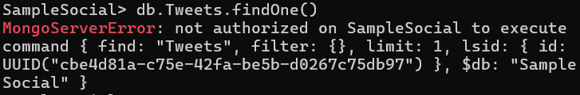

1. Back in the admin window
   1. Create a role in the SampleSocial database called “findTweets”.
   2. Give the role the privilege to “find” in the Tweets collection.

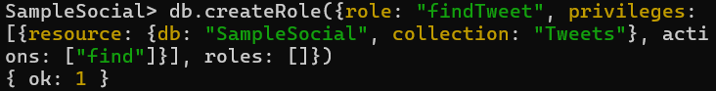

* 1. Give the new role to YourLastNameFind



1. Back in the user window
   1. Run a findOne() command in the Tweets collection, again. It should work this time.

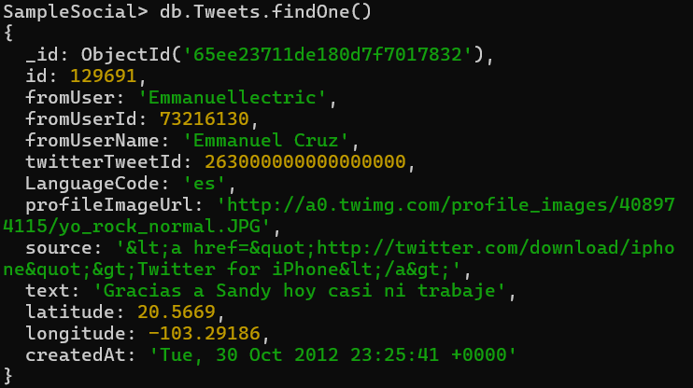

* 1. Run a findOne() command in the Blogs collection. It should fail.

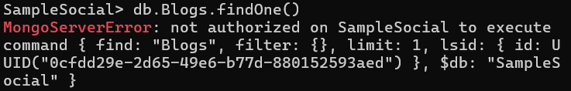

Submit your MS Word document to MyCourses.